MARCH 2026

Town of Onondaga Senior Calendar
0BMONDAY | 1BTUESDAY | 2BWEDNESDAY | 3BTHURSDAY | 4BFRIDAY
2  10-12Noon ‘Busy Hands’  12:30PM Book Club Meeting  1PM Dominoes & Mah Jong  1PM Chi Kung 2PM Tai Chi  6:15PM Strength & Stretch | 3  9-12Noon Income Tax Assistance  (Appointment Needed)  9-12Noon Advanced Art  10-11AM Walking at St. Michael’s  10:15AM Light Weight Exercise  12:30-2:30PM Beginner Art  12:50PM Pass the Ace Card Game | 4  9-12Noon Income Tax Assistance  (Appointment Needed)  9:15-10:15AM Zumba Gold  10:30AM Wii Bowling  11-12Noon Senior Tap  1-3PM Mah Jong | 5  9:15AM Strength & Stretch  10-11AM Walking at St. Michael’s  10:30AM Chair Yoga  1PM Popcorn | 6  10-10:50AM    Light Weight Exercise
9  10-12Noon ‘Busy Hands’  12:30PM Book Club Meeting  1PM Dominoes & Mah Jong  1PM Chi Kung 2PM Tai Chi  6:15PM Strength & Stretch | 10  9-12Noon Income Tax Assistance (Appointment Needed)  9-12Noon Advanced Art  10-11AM Walking at St. Michael’s  10:15AM Light Weight Exercise  12:30-2:30PM Beginner Art  12:50PM Pass the Ace Card Game | 11  9-12Noon Income Tax Assistance  (Appointment Needed)  9:15-10:15AM Zumba Gold  10:30AM Wii Bowling  11-12Noon Senior Tap  1-3PM Mah Jong | 12  9:15AM Strength & Stretch  10-11AM Walking at St. Michael’s  10:30AM Chair Yoga  1PM Bingo For Bucks  6:15PM Strength & Stretch | 13  10-10:50AM  Light Weight Exercise
  16  10-12Noon ‘Busy Hands’  12:30PM Book Club Meeting  1PM Dominoes & Mah Jong  1PM Chi Kung 2PM Tai Chi  6:15PM Strength & Stretch | 17  Happy St. Patrick’s Day Party!  9-12Noon Income Tax Assistance  (Appointment Needed)  9-12Noon Advanced Art  10-11AM Walking at St. Michael’s  10:15AM Light Weight Exercise  12:30-2:30PM Beginner Art | 18  9-12Noon Income Tax Assistance  (Appointment Needed)  9:15-10:15AM Zumba Gold  10:30AM Wii Bowling  11-12Noon Senior Tap  1-3PM Mah Jong | 19  10-11AM Walking at St. Michael’s  10:30AM Chair Yoga  1PM Popcorn  6:15PM Strength & Stretch | 20  10-10:50AM  Light Weight Exercise
23  10-12Noon ‘Busy Hands’  12:30PM Book Club Meeting  1PM Dominoes & Mah Jong  1PM Chi Kung 2PM Tai Chi  6:15PM Strength & Stretch | 24  9-12Noon Income Tax Assistance  (Appointment Needed)  9-12Noon Advanced Art  10-11AM Walking at St. Michael’s  10:15AM Light Weight Exercise  12:30-2:30PM Beginner Art  12:50PM Pass the Ace Card Game | 25  9-12Noon Income Tax Assistance  (Appointment Needed)  9:15-10:15AM Zumba Gold  10:30AM Wii Bowling  11-12Noon Senior Tap  1-3PM Mah Jong | 26  9:15AM Strength & Stretch  10-11AM Walking at St. Michael’s  10:30AM Chair Yoga  1PM Bingo For Bucks  6:15PM Strength & Stretch | 27  10-10:50AM  Light Weight Exercise
30  10-12Noon ‘Busy Hands’  12:30PM Book Club Meeting  1PM Dominoes & Mah Jong  1PM Chi Kung 2PM Tai Chi | 31  9-12Noon Income Tax Assistance  (Appointment Needed)  9-12Noon Advanced Art  10-11AM Walking at St. Michael’s  10:15AM Light Weight Exercise  12:30-2:30PM Beginner Art  12:50PM Pass the Ace Card Game |  | 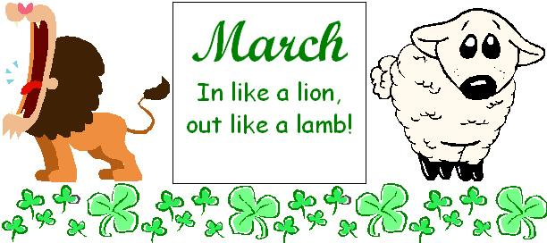 | 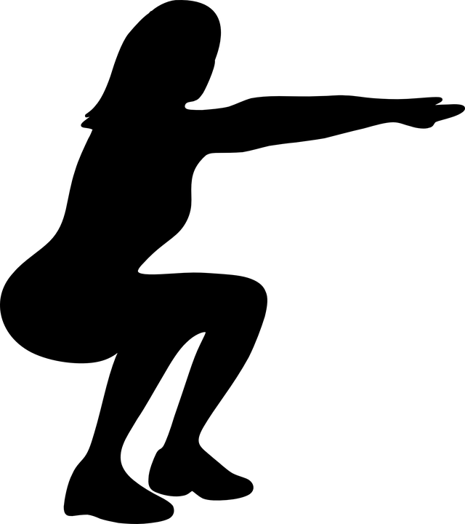

APRIL 2026
Town of Onondaga Senior Calendar
5BMONDAY | 6BTUESDAY | 7BWEDNESDAY | 8BTHURSDAY | 9BFRIDAY
 |  | 1  9-12Noon Income Tax Assistance  (Appointment Needed)  10:30AM Wii Bowling  11-12Noon Senior Tap  1-3PM Mah Jong | 2  10-11AM Walking at St. Michael’s  10:30AM Chair Yoga  12NOON CATERED LUNCH  Rock Shadows Entertaining | 3  10-10:50AM  Light Weight Exercise
6  10-12Noon ‘Busy Hands’  12:30PM Book Club Meeting  1PM Dominoes & Mah Jong  1PM Chi Kung 2PM Tai Chi  6:15PM Strength & Stretch | 7  9-12Noon Income Tax Assistance  (Appointment Needed)  9-12Noon Advanced Art  10-11AM Walking at St. Michael’s  10:15AM Light Weight Exercise  12:30-2:30PM Beginner Art  12:50PM Pass the Ace Card Game | 8  9-12Noon Income Tax Assistance  (Appointment Needed)  9:15-10:15AM Zumba Gold  10:30AM Wii Bowling  11-12Noon Senior Tap  1-3PM Mah Jong | 9  9:15AM Strength & Stretch  10-11AM Walking at St. Michael’s  10:30AM Chair Yoga  11-12 Noon Tech Help with OFL  1PM Popcorn  6:15PM Strength & Stretch | 10  9:00AM-3:30PM  AARP DRIVER  SAFETY CLASS  Registration  Required  10-10:50AM  Light Weight Exercise
13  10-12Noon ‘Busy Hands’  12:30PM Book Club Meeting  1PM Dominoes & Mah Jong  1PM Chi Kung 2PM Tai Chi  6:15PM Strength & Stretch | 14  9-12Noon Advanced Art  10-11AM Walking at St. Michael’s  10:15AM Light Weight Exercise  12:30-2:30PM Beginner Art  12:50PM Pass the Ace Card Game | 15  9:15-10:15AM Zumba Gold  10-2PM Legal Aid (by Appt)  10:30AM Wii Bowling  11-12Noon Senior Tap  1-3PM Mah Jong | 16  9:15AM Strength & Stretch  10-11AM Walking at St. Michael’s  10:30AM Chair Yoga  1PM Bingo For Bucks  6:15PM Strength & Stretch | 17  10-10:50AM  Light Weight Exercise
20  10-12Noon ‘Busy Hands’  12:30PM Book Club Meeting  1PM Dominoes & Mah Jong  1PM Chi Kung 2PM Tai Chi  6:15PM Strength & Stretch | 21  9-12Noon Advanced Art  10-11AM Walking at St. Michael’s  10:15AM Light Weight Exercise  12:30-2:30PM Beginner Art  12:50PM Pass the Ace Card Game | 22  9:15-10:15AM Zumba Gold  10:30AM Wii Bowling  11-12Noon Senior Tap  1-3PM Mah Jong | 23  9:15AM Strength & Stretch  10-11AM Walking at St. Michael’s  10:30AM Chair Yoga  1PM Popcorn  6:15PM Strength & Stretch | 24  10-10:50AM  Light Weight Exercise
27  10-12Noon ‘Busy Hands’  12:30PM Book Club Meeting  1PM Dominoes & Mah Jong  1PM Chi Kung 2PM Tai Chi  6:15PM Strength & Stretch | 28  9-12Noon Advanced Art  10-11AM Walking at St. Michael’s  10:15AM Light Weight Exercise  12:30-2:30PM Beginner Art  12:50PM Pass the Ace Card Game | 29  9:15-10:15AM Zumba Gold  10:30AM Wii Bowling  11-12Noon Senior Tap  1-3PM Mah Jong | 30  9:15AM Strength & Stretch  10-11AM Walking at St. Michael’s  10:30AM Chair Yoga  1PM Bingo For Bucks  6:15PM Strength & Stretch | 